**Product Overview**  
Product Name: New Product

Version: When applicable

Phase: When applicable

Date: date  
  
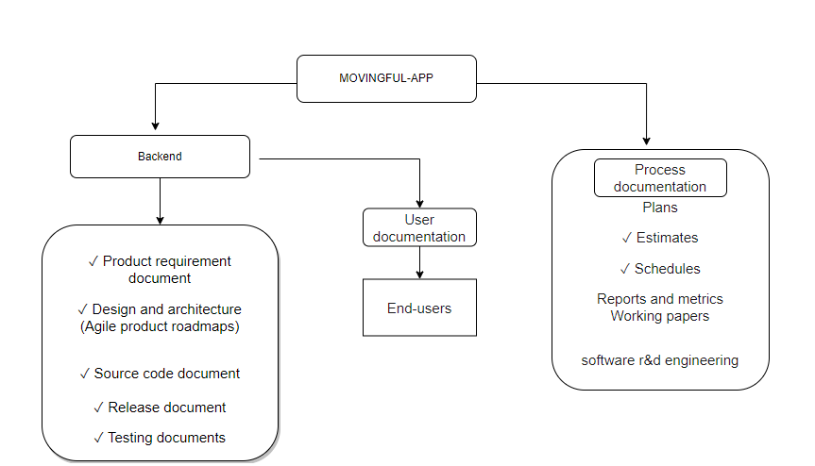  
  
Product Requirements Document Template  
  
**1.** **Objective**

|  |  |
| --- | --- |
| Vision |  |
| Goals |  |
| initiatives |  |

2. Release

|  |  |
| --- | --- |
| Release | Release name |
| Date | Release date |
| initiatives | Initiative that the relates to |
| Milestones | Release milestones |
| features | Features included in the release |
| dependencies | Release dependencies |

## Product Features

**Feature**

|  |  |
| --- | --- |
| Feature | Feature |
| Description | Description of new feature |
| purpose | Task or action |
| User problem | Customer Pain point |
| User value | How the proposed value helps the customer |

**User Flow and design Flow charts  
(Sample)**  
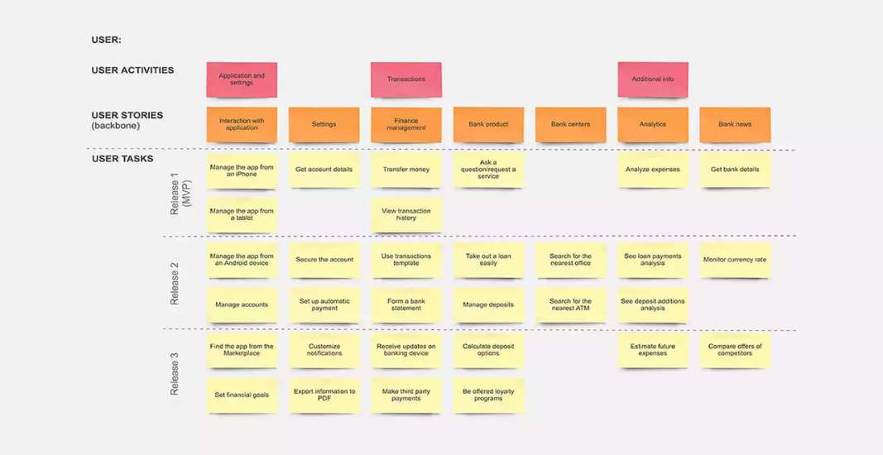

Analytics:

|  |  |  |  |
| --- | --- | --- | --- |
| Key performance indicator | baseline | target | timeframe |
|  |  |  |  |

Future work

|  |  |  |  |
| --- | --- | --- | --- |
| Future features | purpose | priority | timeframe |
|  |  |  |  |

**Backend Related docs:**  
 **Software requirements:**  
 what we have install or what we need access to start work  
  
**Design/Architecture:**  
 A pictorial representation  
  
**Databases:**   
  
Table name:

|  |  |  |  |
| --- | --- | --- | --- |
| Parameter/field | description | priority | notes |
|  |  |  |  |

**API-Documentation:**  
 What that particular js file is doing  
 requested input  
 expected output  
  
**Testcases**: